TASK 2:Exploratory Data Analysis(EDA

- INTRODUCTION:
This dataset contains information about students including their names,mobile number,grades,marks,comments,roll no ,school name ,address.The purpose of this analysis is to understand patterns and relationships within the data .

- DATASET DESCRIPTION:

- Total number of rows:500
- Total number of columns:10
- Column names: student_names,phone_no,maths,physics ,chemistry ,grade, comment ,roll no,school name ,student address

- DATA TYPES:

- Name: categorical data
- Phone number:categorical data
- Subjects:categorical data
- Grade:categorical data
- Comment:categorical data
- Roll no: numerical data(identifier)
- School name:categorical data
- Student address: categorical data

- STATISTICAL ANALYSIS:

Since the dataset mainly contains categorical data ,statistical analysis is performed using frequency counts.

- Number of students with grade A:21
- Number of students with grade A+:2
- Number of students with grade B:94
- Number of students with grade B+:53
- Number of students with grade C:125
- Number of students with grafe D:169
- Most common grade:D
As the dataset contains mostly categorical variables ,measures like mean and median are not applicable

- Observations:
- The majority of students fall under grade D ,indicating that a large number of students have lower academic performance
- Grade C is the second most common grade ,showing that many students have average performance
- Grade B also has a significamt number of students ,indicating moderate performance levels
- Very few students achieved Grade A +,which shows that high academic performance is limited
- Overall the distribution of grades suggests that most students are performing at an average to performing at an average to below-average level.

- DATA ISSUES:

- No major missing values were found in dataset
- Most of data is categorical .so numerical statistical methods like mean ,median, are not applicable.
- Roll numbers and phone numbers are numerical in form but are used as identifiers ,so they were treated as categorical data.

- CONCLUSION:

The analysis of the dataset shows that the majority of students fall under grade D,indicating that overall academic performance is on the lower side. A significant number of students are in grade B and C ,representing average performance levels.very few students achieved grade A ,showing limited high performance.
Overall the performance suggest that there is a need for improvement in student performance ,and more focus should be given to help students achieve higher grades.

- DATASET:
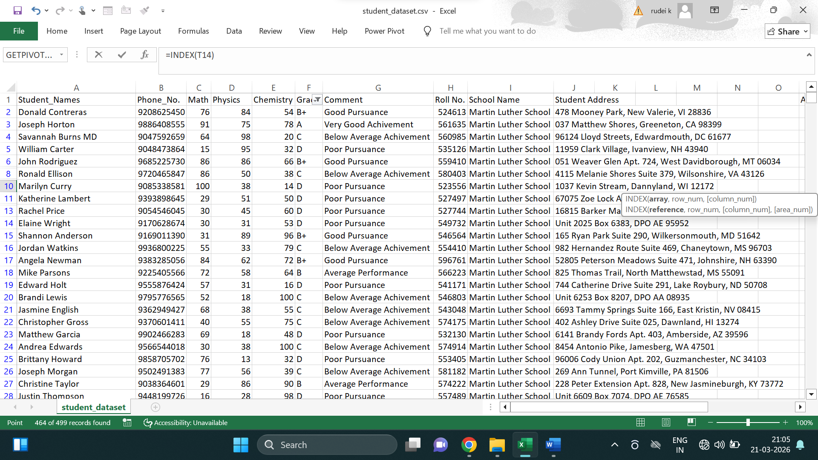
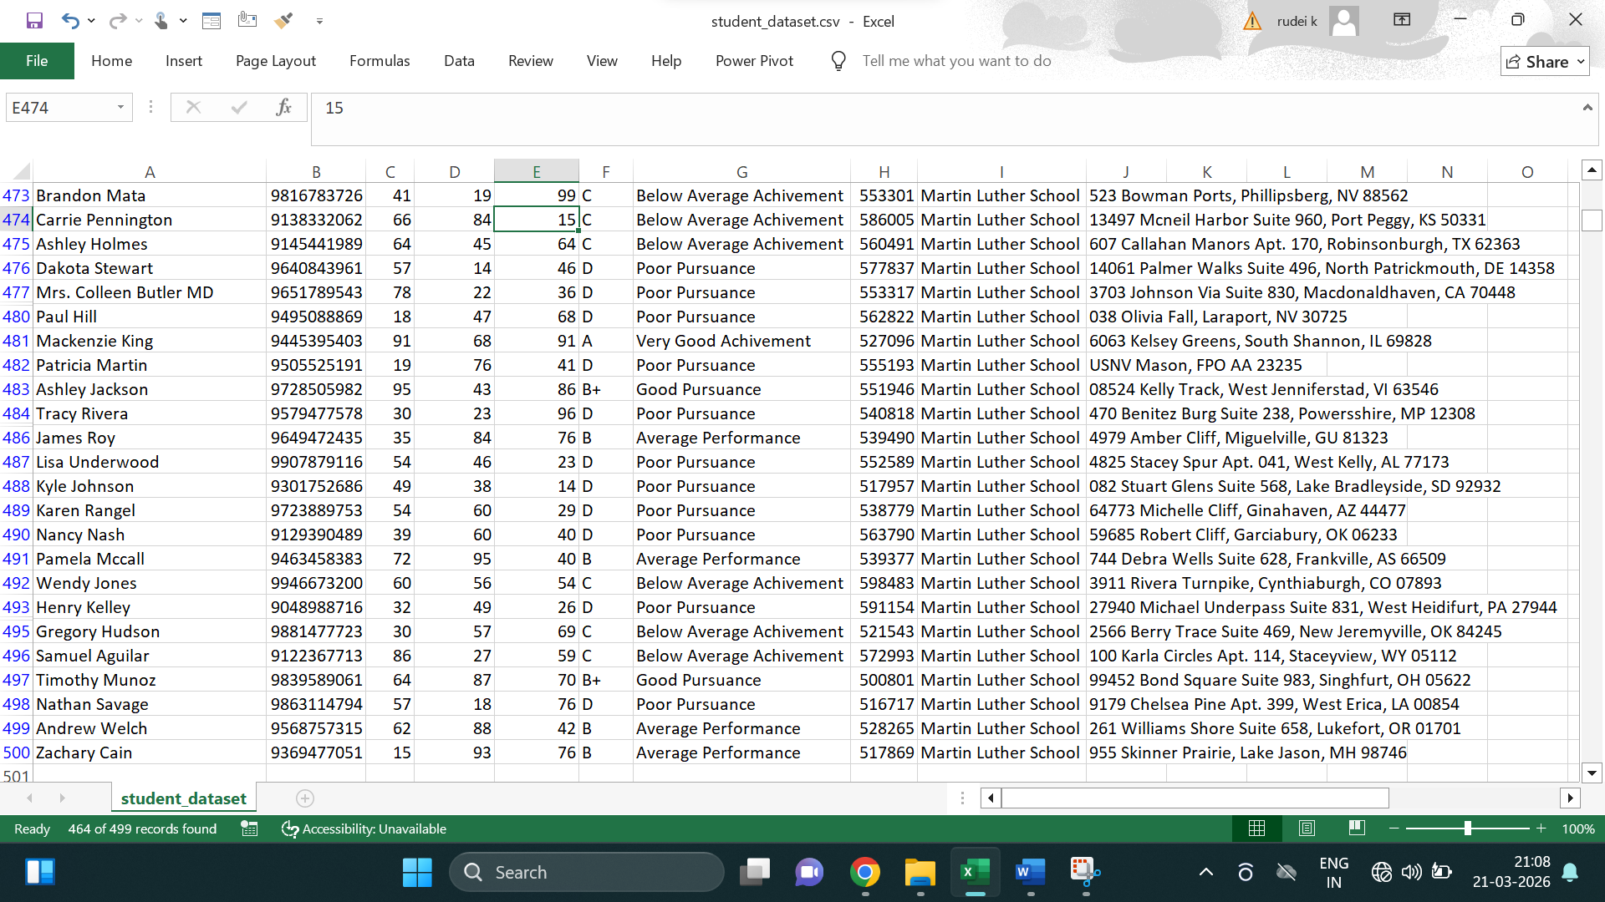

TASK 3:DATA VISUALIZATION

- INTRODUCTION:
Data visualization is the process of representing data in graphical form such as charts and graphs .It helps in understanding patterns ,trends and insights in an easy and clear way.

- DATASET DESCRIPTION:
The dataset contains information about students including their grades and other details .The total number of records in the dataset is 500.
- DATA PREPARATION:
For visualization ,grade data was grouped and counted
- Grade A=21
- Grade A+=2
- Grade B=94
- Grade B+=53
- Grade C=125
- Grade D=169
Grades such as A+ and B+ were combined with A and
- VISUALIZATION:

- CONCLUSION: The data visulization of student grades clearly shows the overall performance distribution .It is observed that the majority of student fall in grade D and Grade B,Overall data visualization makes it easier to analyze patterns,compare values and draw meaningful insights for better decision making.

